Rock .NET 4.6.2 migration cheat sheet

The normal process of upgrading a Visual Studio solution to a newer version .NET can be messy. Especially with an extensible project like Rock. So, if you have a custom visual studio solution with non-core plugin libraries, this cheat sheet simplifies the process

# Update Visual Studio

Use the Visual Studio Installer to install the .NET Framework 4.6.2 targeting pack

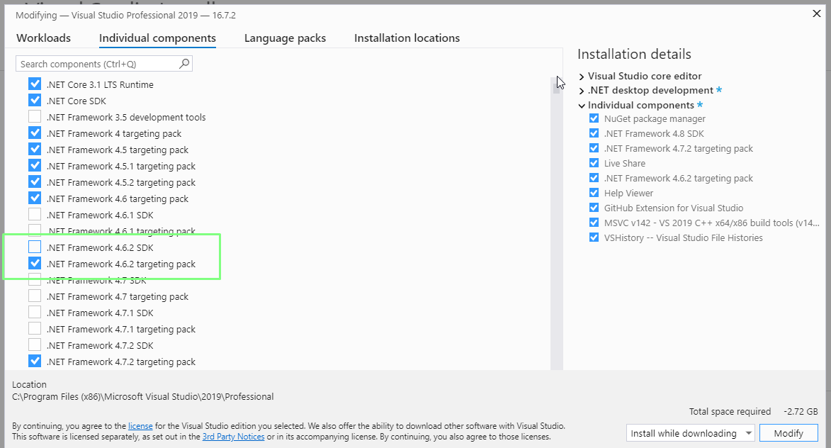

# Get the 4.6.2 version of Rock

If you haven’t already, get a version of Rock that is 4.6.2. Depending on how you maintain your solution, that would from your github fork, or the Rock SDK.

# Packages.config

Use a search/replace to update the packages.config files in your solution directory

1. Find: targetFramework="net452"

Replace: targetFramework="net462"

File types: packages.config

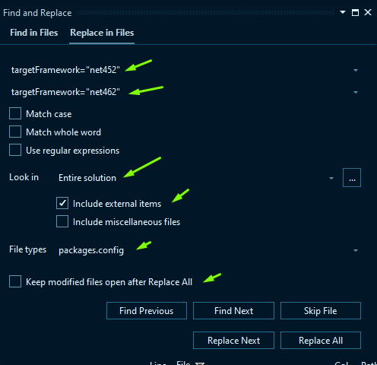

1. Close Visual Studio
2. Delete packages folder

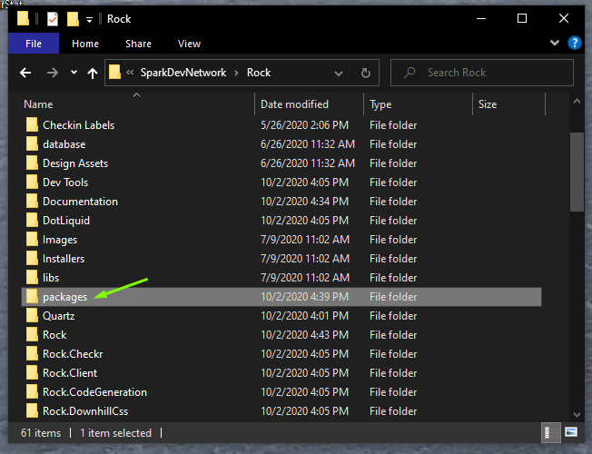

1. Reopen Visual Studio
2. Restore Nuget Packages

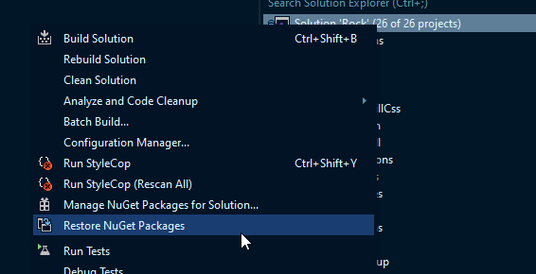

# Edit .refresh files

Most of the .refresh files don’t need to be changed, except for these